**The title of your contribution to Workshop on Ultracold Molecules 2025**

**Michał Tomza1,†, Mihai Suster2, Mieczysław Wolfke1**

1Faculty of Physics, University of Warsaw, Pasteura 5, 02-093 Warszawa, Poland

2Candela Foundation, Grochowska 357 m. 513, 03-822 Warszawa, Poland

**†** corresponding author’s email: [michal.tomza@fuw.edu.pl](mailto:michal.tomza@fuw.edu.pl)

Please follow these rules to ensure the happiness of the organizers and the beauty of the book of abstract:

* write your abstract in Times New Roman 11pt,
* underline name of the presenting author,
* indent the first line of each paragraph,
* do not exceed **1 page,**
* include figures in the text with max. 2MB size,
* write the caption outside the figure frame (see Figure 1 as an example),
* insert your references and cite as [1] and [2],
* submit your abstract following procedure described at www.ultracold-molecules-2025.pl.

The second edition of the Workshop on Ultracold Molecules 2025 is set to be held in the vibrant city of Warsaw, Poland, from June 24 to 27, 2025. This four-day event will convene leading international experts in the field of ultracold molecules to exchange ideas, share advancements, and explore new research directions. Topics covered will include cutting-edge techniques in the formation, manipulation, trapping, and laser cooling of ultracold molecules, alongside their applications in areas such as quantum physics, cold chemistry, and precision measurement.

Organized jointly by the University of Warsaw and the Candela Foundation, the workshop promises a rich and intensive program. We look forward to seeing the latest developments in the field and to the new ideas that will emerge from this gathering of minds in Warsaw.

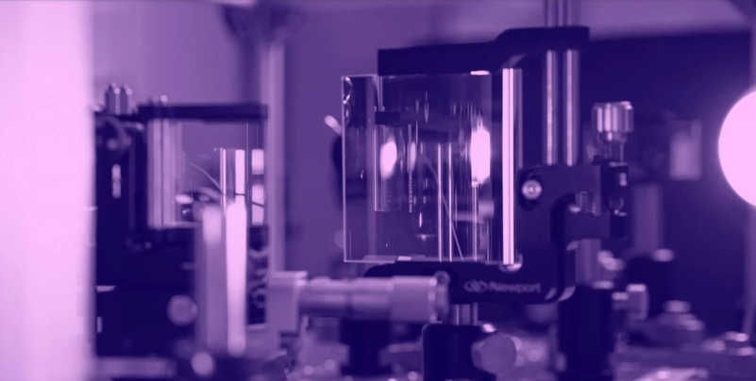

Figure 1: Caption of your figure: Times New Roman, 11 points.

Acknowledgments

Your acknowledgment text goes here.

**References**

1. N. White and G. Black*, Nature Materials* **6**, 9 (2024).
2. F. Bennett, X.Y. Harrison, and F. Foster, *Optica* **15**, 11220 (2023).